DBI202 – Project and Task Management DATABASE System
FPT UNIVERSITY
DBI202.E1.Bl5
Group 4
Teacher: Mai Ngọc Lương

ASSIGNMENT

TABLE OF CONTENTS
TABLE OF CONTENTS 1
I) PHẦN I: GIỚI THIỆU THÀNH VIÊN NHÓM 3
II) PHẦN II: KẾ HOẠCH, PHÂN CÔNG CÁC THÀNH VIÊN 3
1. Kế hoạch thực hiện 3
III) QUÁ TRÌNH TRIỂN KHAI 4
IV. PHÁT BIỂU BÀI TOÁN 6
1) Problem description and context 6
2) Objects and scope 6
3) System requirements and management objectives 6
V. QUY TRÌNH NGHIỆP VỤ 7
1) Overall business process 7
2) Detailed business processes 7
A. Task assignment process 7
B. Progress reporting process 8
C. Employee performance evaluation process 8
VI. MÔ HÌNH ERD 8
VII. MÔ TẢ ĐẶC TẢ DỮ LIỆU VÀ THỐNG KÊ CÁC RÀNG BUỘC 9
1. Data Dictionary 9
A. Data Dictionary – Table: Projects 9
B. Data Dictionary – Table: Employees 9
C. Data Dictionary – Table: TaskStatus 10
D. Data Dictionary – Table: Tasks 10
E. Data Dictionary – Table: TaskAssignments 10
F. Data Dictionary – Table: WorkLogs 11
G. Data Dictionary – Table: ProjectDocuments 11
H. Data Dictionary – Table: ProgressReports 11
I. Data Dictionary – Table: ProjectCosts 12
2. Data Dictionary 13
A. Projects – Tasks Relationship 13
Constraint Type 13
Description 13
Implementation 13
Purpose 13
B. TaskStatus – Tasks Relationship 13
Constraint Type 13
Description 13
Implementation 13
Purpose 13
C. Tasks – TaskAssignments – Employees Relationship 13
Constraint Type 14
Description 14
Implementation 14
Purpose 14
D. Tasks – WorkLogs – Employees Relationship 14
Constraint Type 14
Description 14
Implementation 14
Purpose 14
E. Tasks – ProgressReports – Employees Relationship 15
Constraint Type 15
Description 15
Implementation 15
Purpose 15
F. Projects – ProjectDocuments – Employees Relationship 15
Constraint Type 15
Description 15
Implementation 15
Purpose 15
J. Projects – ProjectCosts Relationship 16
Constraint Type 16
Description 16
Implementation 16
Purpose 16
G. Projects – PerformanceReviews – Employees Relationship 16
Constraint Type 16
Description 16
Implementation 16
Purpose 16
VIII. THỰC HÀNH SQL 17
A. Create Database 17
B. Create Database Tables 17
C. Initializing data 21
D. SQL Queries for statistics 25
E. Views 30
F. Stored Procedures 32
G. Triggers 35
PHẦN IX: KẾT QUẢ ĐẠT ĐƯỢC 39
PHẦN X: KẾT LUẬN 39

PHẦN I: GIỚI THIỆU THÀNH VIÊN NHÓM
Đàm Thận Minh Nhật
Đỗ Huy Hoàng
Trần Trí Ngữ
Nguyễn Minh Tú
Phạm Tiến Hải
Đoàn Phương Duy

PHẦN II: KẾ HOẠCH, PHÂN CÔNG CÁC THÀNH VIÊN
Copy phần kế hoạch cuối cùng

1. Kế hoạch thực hiện
- Ngày 9/12: Phân tích yêu cầu bài toán, xác định thực thể
- Ngày 10/12: Thiết kế ERD, chuẩn hóa dữ liệu
- Ngày 11/12: Viết script SQL tạo CSDL và bảng
- Ngày 12/12: Hoàn thiện báo cáo và kiểm tra dữ liệu

- Phân công công việc cho từng thành viên

Thành Viên | Công Việc
Đàm Thận Minh Nhật | Quy trình nghiệp vụ, viết tài liệu
Đỗ Huy Hoàng | Thiết kế ERD, xác định quan hệ
Đoàn Phương Duy | Thiết kế bảng và ràng buộc, thực hành SQL
Trần Trí Ngữ | Xây dựng slide, insert dữ liệu
Phạm Tiến Hải | Phát biểu bài toán, viết tài liệu
Nguyễn Minh Tú | Vẽ ERD , xây dựng slide

- Thành viên nào tham gia tích cực cần cộng điểm
Đàm Thận Minh Nhật
Đỗ Huy Hoàng
Trần Trí Ngữ
Nguyễn Minh Tú
Phạm Tiến Hải
Đoàn Phương Duy

QUÁ TRÌNH TRIỂN KHAI
Tổng số buổi họp, làm việc online, offline
Tổng số buổi họp: 6 buổi (5 online, 1 offline)
- Đưa nội dung của biên bản cuộc họp
Nội dung họp:
- Thảo luận yêu cầu đề tài
- Xây dựng ERD
- Kiểm tra ràng buộc dữ liệu
- Hoàn thiện báo cáo
- Công cụ sử dụng
Microsoft SQL Server
Draw.io (vẽ ERD)
Microsoft Word
- Đưa một số hình ảnh trong các lần họp
Link Videos, hình ảnh (nếu có)
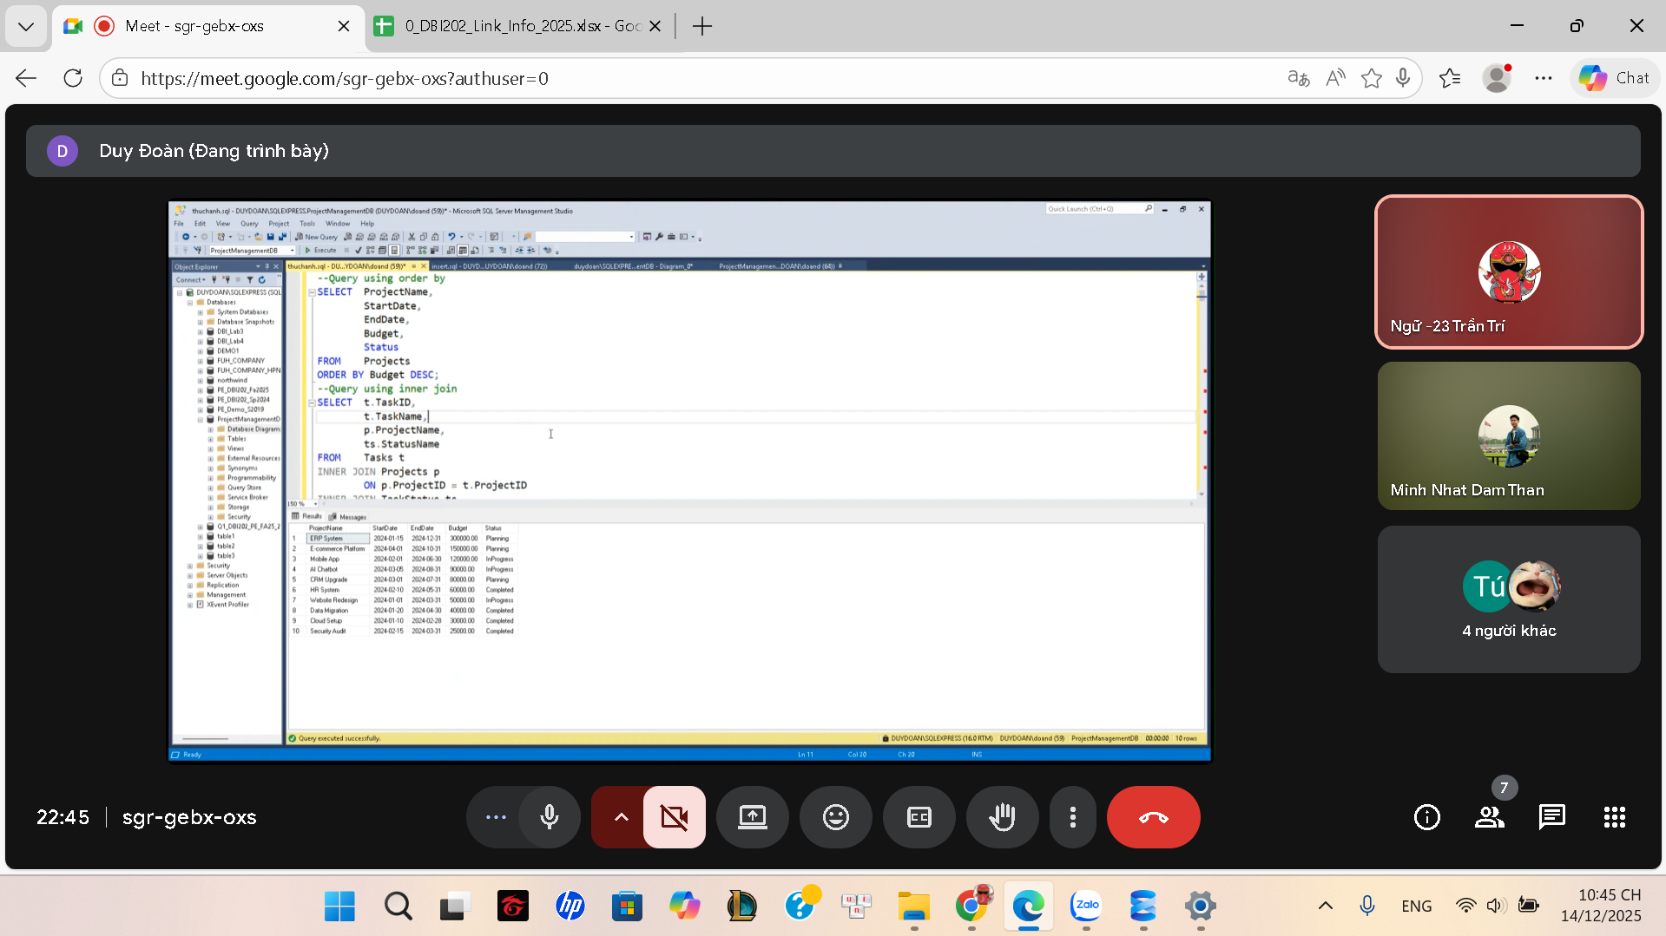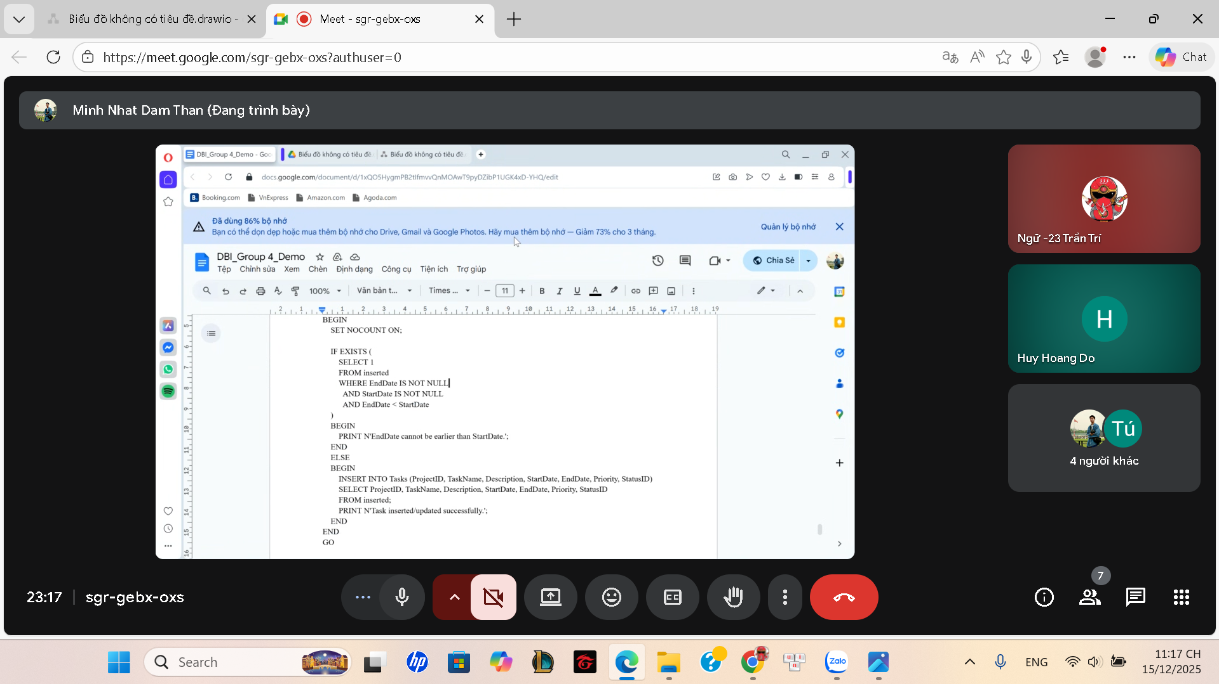

IV. PHÁT BIỂU BÀI TOÁN

Problem description and context
Nowadays, organizations often execute multiple projects simultaneously, involving many tasks and employees. However, project management activities such as task assignment, progress tracking, cost control, and performance evaluation are still handled manually in many organizations using spreadsheets or disconnected tools. This leads to difficulties in monitoring overall progress, consolidating data, and generating accurate reports.
Based on a practical survey, several key issues were identified:
- Each project consists of multiple tasks, but each task belongs to only one project.
- Tasks can be assigned to multiple employees, and each employee may participate in multiple tasks.
- Task status must be tracked throughout the execution process.
- Working time and project costs are not managed in a centralized manner.
- Employee performance evaluation lacks comprehensive supporting data.
Therefore, a centralized database system is required to support effective project and task management.

Objects and scope
The objects managed by the system include:
- Projects
- Tasks
- Employees
- Task assignments
- Working time records
- Project costs
- Documents and progress reports
Performance evaluations
The scope of the system focuses on designing and implementing a database to support project and task management within an organization. User interface features and external system integrations are outside the scope of this project.

System requirements and management objectives
The system is expected to meet the following requirements and objectives:
- Manage project information and related tasks.
- Assign and track employee participation in tasks.
- Monitor task status and work progress.
- Record working time and project costs.
- Support employee performance evaluation by project.

V. QUY TRÌNH NGHIỆP VỤ

Overall business process
- Project creation
The manager creates a new project and enters basic information such as project name, description, start date, end date, budget, and project status.
- Task creation for the project
After the project is created, it is divided into specific tasks. Each task is associated with a project and includes information such as task name, execution time, priority level, and status.
- Employee assignment
Employees are assigned to tasks based on their roles and expertise. A task may be assigned to multiple employees.
- Working time recording
During task execution, employees record their daily working time for each task to support progress tracking and performance evaluation.
- Progress reporting
Employees or task leaders update progress reports to reflect task completion levels and any arising issues.
- Cost management
Costs incurred during project execution, such as labor, equipment, or software expenses, are recorded and managed by project.
- Performance evaluation
After the project or a specific phase is completed, managers evaluate employee performance based on progress, working time, and achieved results.

Detailed business processes

Task assignment process
- The manager selects the project for task assignment.
- The system displays the list of tasks belonging to the selected project.
- The manager chooses a specific task.
- The manager selects suitable employees and assigns roles (Developer, Tester, Leader, etc.).
- The system saves the assignment information and updates the task status.
- Employees are notified of their assigned tasks.

Progress reporting process
- Employees access the system and select the tasks they are working on.
- Employees update the task completion percentage.
- Employees add notes about issues or difficulties encountered.
- The system stores progress reports over time.
- Managers monitor and evaluate the progress of each task.

Employee performance evaluation process
- After a project or task is completed, the manager retrieves relevant data.
- The system aggregates information on working time, progress, and task results.
- The manager assigns scores and comments on employee performance.
- Evaluation results are stored and linked to the corresponding project.
- Performance data is used for reporting and future management decisions.

VI. MÔ HÌNH ERD
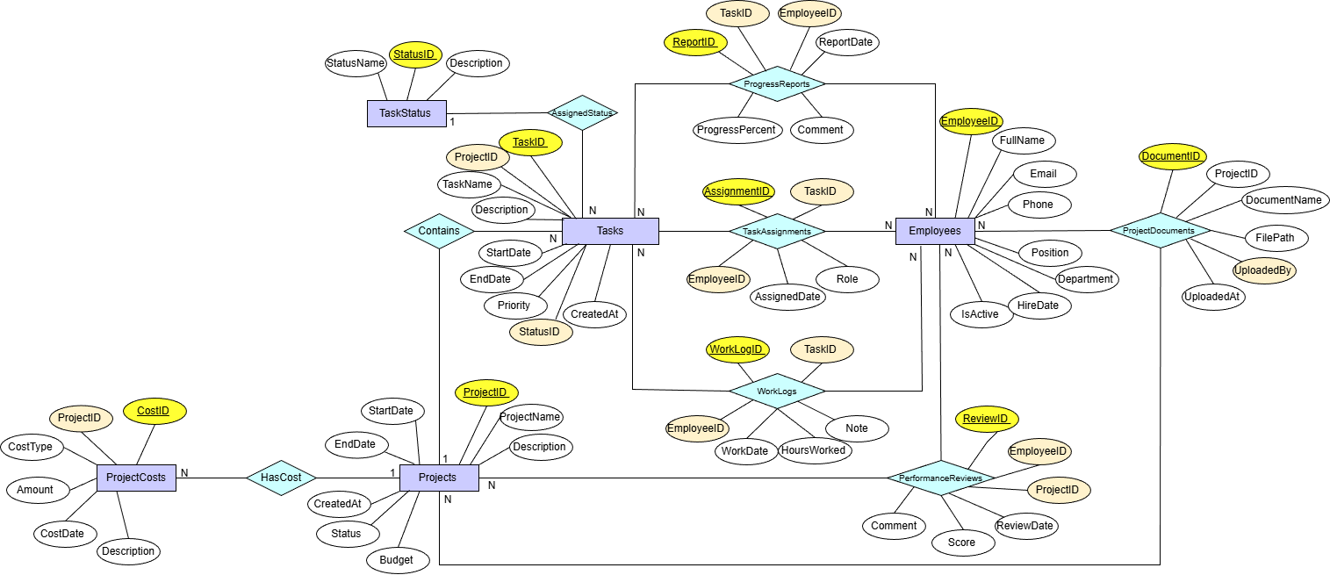

VII. MÔ TẢ ĐẶC TẢ DỮ LIỆU VÀ THỐNG KÊ CÁC RÀNG BUỘC

Data Dictionary

Data Dictionary – Table: Projects
No | Field Name | Data Type | Size | Format | Description
1 | ProjectID | INT |  | PK, Identity | Project identifier
2 | ProjectName | NVARCHAR | 200 |  | Project name
3 | Description | NVARCHAR | MAX |  | Project description
4 | StartDate | DATE |  | DD/MM/YYYY | Project start date
5 | EndDate | DATE |  | DD/MM/YYYY | Project end date
6 | Budget | DECIMAL | 18,2 |  | Project budget
7 | Status | NVARCHAR | 50 |  | Project status
8 | CreatedAt | DATETIME |  | DD/MM/YYYY HH:MM | Creation date

Data Dictionary – Table: Employees
No | Field Name | Data Type | Size | Format | Description
1 | EmployeeID | INT |  | PK, Identity | Employee identifier
2 | FullName | NVARCHAR | 150 |  | Employee full name
3 | Email | NVARCHAR | 150 |  | Email address (Unique)
4 | Phone | NVARCHAR | 20 |  | Phone number
5 | Position | NVARCHAR | 100 |  | Job position
6 | Department | NVARCHAR | 100 |  | Department
7 | HireDate | DATE |  | DD/MM/YYYY | Hiring date
8 | IsActive | BIT |  |  | Employment status

Data Dictionary – Table: TaskStatus
No | Field Name | Data Type | Size | Format | Description
1 | StatusID | INT |  | PK, Identity | Status identifier
2 | StatusName | NVARCHAR | 50 |  | Status name
3 | Description | NVARCHAR | 255 |  | Status description

Data Dictionary – Table: Tasks
No | Field Name | Data Type | Size | Format | Description
1 | TaskID | INT |  | PK, Identity | Task identifier
2 | ProjectID | INT |  | FK | Related project
3 | TaskName | NVARCHAR | 200 |  | Task name
4 | Description | NVARCHAR | MAX |  | Task description
5 | StartDate | DATE |  | DD/MM/YYYY | Task start date
6 | EndDate | DATE |  | DD/MM/YYYY | Task end date
7 | Priority | NVARCHAR | 50 |  | Task priority
8 | StatusID | INT |  | FK | Task status
9 | CreatedAt | DATETIME |  | DD/MM/YYYY HH:MM | Creation date

Data Dictionary – Table: TaskAssignments
No | Field Name | Data Type | Size | Format | Description
1 | AssignmentID | INT |  | PK, Identity | Assignment identifier
2 | TaskID | INT |  | FK | Task identifier
3 | EmployeeID | INT |  | FK | Employee identifier
4 | AssignedDate | DATE |  | DD/MM/YYYY | Assignment date
5 | Role | NVARCHAR | 100 |  | Assigned role

Data Dictionary – Table: WorkLogs
No | Field Name | Data Type | Size | Format | Description
1 | WorkLogID | INT |  | PK, Identity | Work log identifier
2 | TaskID | INT |  | FK | Task identifier
3 | EmployeeID | INT |  | FK | Employee identifier
4 | WorkDate | DATE |  | DD/MM/YYYY | Working date
5 | HoursWorked | DECIMAL | 5,2 |  | Working hours
6 | Note | NVARCHAR | 255 |  | Notes

Data Dictionary – Table: ProjectDocuments
No | Field Name | Data Type | Size | Format | Description
1 | DocumentID | INT |  | PK, Identity | Document identifier
2 | ProjectID | INT |  | FK | Related project
3 | DocumentName | NVARCHAR | 200 |  | Document name
4 | FilePath | NVARCHAR | 500 |  | File location
5 | UploadedBy | INT |  | FK | Uploaded by employee
6 | UploadedAt | DATETIME |  | DD/MM/YYYY HH:MM | Upload time

Data Dictionary – Table: ProgressReports
No | Field Name | Data Type | Size | Format | Description
1 | ReportID | INT |  | PK, Identity | Report identifier
2 | TaskID | INT |  | FK | Task identifier
3 | EmployeeID | INT |  | FK | Employee identifier
4 | ReportDate | DATE |  | DD/MM/YYYY | Report date
5 | ProgressPercent | INT |  | 0–100 | Completion percentage
6 | Comment | NVARCHAR | MAX |  | Report comment

Data Dictionary – Table: ProjectCosts
No | Field Name | Data Type | Size | Format | Description
1 | CostID | INT |  | PK, Identity | Cost identifier
2 | ProjectID | INT |  | FK | Project identifier
3 | CostType | NVARCHAR | 100 |  | Cost type
4 | Amount | DECIMAL | 18,2 |  | Cost amount
5 | CostDate | DATE |  | DD/MM/YYYY | Cost date
6 | Description | NVARCHAR | 255 |  | Cost description
- Data Dictionary – Table: PerformanceReviews
No | Field Name | Data Type | Size | Format | Description
1 | ReviewID | INT |  | PK, Identity | Review identifier
2 | EmployeeID | INT |  | FK | Employee identifier
3 | ProjectID | INT |  | FK | Project identifier
4 | ReviewDate | DATE |  | DD/MM/YYYY | Review date
5 | Score | INT |  | 1–10 | Performance score
6 | Comment | NVARCHAR | 255 |  | Review comment

Data Dictionary

Projects – Tasks Relationship

Constraint Type
- Foreign Key Constraint

Description
- Each task must belong to exactly one project.
- A project can contain multiple tasks.

Implementation
- Tasks.ProjectID references Projects.ProjectID.

Purpose
- Ensures that a task cannot exist without an associated project.
- Prevents orphan task records.

TaskStatus – Tasks Relationship

Constraint Type
- Foreign Key Constraint

Description
- Each task is assigned one status.
- A task status can be applied to multiple tasks.

Implementation
- Tasks.StatusID references TaskStatus.StatusID.

Purpose
- Ensures that all tasks have a valid predefined status.
- Maintains consistency in task progress tracking.

C. Tasks – TaskAssignments – Employees Relationship

Constraint Type
- Associative (Junction Table) with Foreign Keys

Description
- Represents a many-to-many relationship between tasks and employees.
- A task can be assigned to multiple employees.
- An employee can be assigned to multiple tasks.

Implementation
- TaskAssignments.TaskID references Tasks.TaskID.
- TaskAssignments.EmployeeID references Employees.EmployeeID.

Purpose
- Ensures valid task–employee assignments.
- Stores additional assignment information such as role and assigned date.

D. Tasks – WorkLogs – Employees Relationship

Constraint Type
- Foreign Key Constraints

Description
- Records working time of employees on tasks.
- A task can have multiple work logs.
- An employee can create multiple work logs.

Implementation
- WorkLogs.TaskID references Tasks.TaskID.
- WorkLogs.EmployeeID references Employees.EmployeeID.

Purpose
- Ensures work logs are linked to valid tasks and employees.
- Supports accurate tracking of working hours.

E. Tasks – ProgressReports – Employees Relationship

Constraint Type
- Foreign Key Constraints

Description
- Tracks task progress updates reported by employees.
- A task can have multiple progress reports.
- Each progress report is submitted by one employee.

Implementation
- ProgressReports.TaskID references Tasks.TaskID.
- ProgressReports.EmployeeID references Employees.EmployeeID.

Purpose
- Guarantees that progress reports are associated with valid tasks and employees.
- Supports monitoring of task completion over time.

F. Projects – ProjectDocuments – Employees Relationship

Constraint Type
- Foreign Key Constraints

Description
- Stores documents related to projects.
- A project can have multiple documents.
- Each document is uploaded by one employee.

Implementation
- ProjectDocuments.ProjectID references Projects.ProjectID.
- ProjectDocuments.UploadedBy references Employees.EmployeeID.

Purpose
- Ensures documents are linked to existing projects and employees.
- Maintains accountability for document uploads.

J. Projects – ProjectCosts Relationship

Constraint Type
- Foreign Key Constraint

Description
- Records costs incurred by projects.
- A project can have multiple cost records.

Implementation
- ProjectCosts.ProjectID references Projects.ProjectID.

Purpose
- Ensures that all cost records belong to valid projects.
- Supports accurate project cost management.

G. Projects – PerformanceReviews – Employees Relationship

Constraint Type
- Associative Relationship with Foreign Keys

Description
- Represents employee performance evaluations within projects.
- An employee can be evaluated multiple times across different projects.
- A project can have performance reviews for multiple employees.

Implementation
- PerformanceReviews.ProjectID references Projects.ProjectID.
- PerformanceReviews.EmployeeID references Employees.EmployeeID.

Purpose
- Ensures performance reviews are linked to valid employees and projects.
- Supports fair and structured performance evaluation.

WORKS
Student name:.............| …………………….. (.....%)
Student name:.............| …………………….. (.....%)
Student name:.............| …………………….. (.....%)
Student name:.............| …………………….. (.....%)
Student name:.............| …………………….. (.....%)
Student name:.............| …………………….. (.....%)

VIII. THỰC HÀNH SQL

Create Database
/* ================================
CREATE DATABASE
================================ */
CREATE DATABASE ProjectManagementDB;
GO

USE ProjectManagementDB;
GO

Create Database Tables
/* ================================
TABLE: Projects
================================ */
CREATE TABLE Projects (
ProjectID INT IDENTITY(1,1) PRIMARY KEY,
ProjectName NVARCHAR(200) NOT NULL,
Description NVARCHAR(MAX),
StartDate DATE NOT NULL,
EndDate DATE,
Budget DECIMAL(18,2) CHECK (Budget >= 0),
Status NVARCHAR(50) NOT NULL,
CreatedAt DATETIME DEFAULT GETDATE()
);
GO

/* ================================
TABLE: Employees
================================ */
CREATE TABLE Employees (
EmployeeID INT IDENTITY(1,1) PRIMARY KEY,
FullName NVARCHAR(150) NOT NULL,
Email NVARCHAR(150) NOT NULL UNIQUE,
Phone NVARCHAR(20),
Position NVARCHAR(100),
Department NVARCHAR(100),
HireDate DATE,
IsActive BIT DEFAULT 1
);
GO

/* ================================
TABLE: TaskStatus
================================ */
CREATE TABLE TaskStatus (
StatusID INT IDENTITY(1,1) PRIMARY KEY,
StatusName NVARCHAR(50) NOT NULL,
Description NVARCHAR(255)
);
GO

/* ================================
TABLE: Tasks
================================ */
CREATE TABLE Tasks (
TaskID INT IDENTITY(1,1) PRIMARY KEY,
ProjectID INT NOT NULL,
TaskName NVARCHAR(200) NOT NULL,
Description NVARCHAR(MAX),
StartDate DATE,
EndDate DATE,
Priority NVARCHAR(50),
StatusID INT NOT NULL,
CreatedAt DATETIME DEFAULT GETDATE(),

CONSTRAINT FK_Tasks_Projects
FOREIGN KEY (ProjectID)
REFERENCES Projects(ProjectID),

CONSTRAINT FK_Tasks_TaskStatus
FOREIGN KEY (StatusID)
REFERENCES TaskStatus(StatusID),

CONSTRAINT CK_Tasks_Date
CHECK (EndDate IS NULL OR StartDate <= EndDate)
);
GO

/* ================================
TABLE: TaskAssignments
================================ */
CREATE TABLE TaskAssignments (
AssignmentID INT IDENTITY(1,1) PRIMARY KEY,
TaskID INT NOT NULL,
EmployeeID INT NOT NULL,
AssignedDate DATE DEFAULT GETDATE(),
Role NVARCHAR(100),

CONSTRAINT FK_TaskAssignments_Tasks
FOREIGN KEY (TaskID)
REFERENCES Tasks(TaskID),

CONSTRAINT FK_TaskAssignments_Employees
FOREIGN KEY (EmployeeID)
REFERENCES Employees(EmployeeID)
);
GO

/* ================================
TABLE: WorkLogs
================================ */
CREATE TABLE WorkLogs (
WorkLogID INT IDENTITY(1,1) PRIMARY KEY,
TaskID INT NOT NULL,
EmployeeID INT NOT NULL,
WorkDate DATE NOT NULL,
HoursWorked DECIMAL(5,2) NOT NULL CHECK (HoursWorked > 0),
Note NVARCHAR(255),

CONSTRAINT FK_WorkLogs_Tasks
FOREIGN KEY (TaskID)
REFERENCES Tasks(TaskID),

CONSTRAINT FK_WorkLogs_Employees
FOREIGN KEY (EmployeeID)
REFERENCES Employees(EmployeeID)
);
GO

/* ================================
TABLE: ProjectDocuments
================================ */
CREATE TABLE ProjectDocuments (
DocumentID INT IDENTITY(1,1) PRIMARY KEY,
ProjectID INT NOT NULL,
DocumentName NVARCHAR(200),
FilePath NVARCHAR(500),
UploadedBy INT NOT NULL,
UploadedAt DATETIME DEFAULT GETDATE(),

CONSTRAINT FK_ProjectDocuments_Projects
FOREIGN KEY (ProjectID)
REFERENCES Projects(ProjectID),

CONSTRAINT FK_ProjectDocuments_Employees
FOREIGN KEY (UploadedBy)
REFERENCES Employees(EmployeeID)
);
GO

/* ================================
TABLE: ProgressReports
================================ */
CREATE TABLE ProgressReports (
ReportID INT IDENTITY(1,1) PRIMARY KEY,
TaskID INT NOT NULL,
EmployeeID INT NOT NULL,
ReportDate DATE DEFAULT GETDATE(),
ProgressPercent INT CHECK (ProgressPercent BETWEEN 0 AND 100),
Comment NVARCHAR(MAX),

CONSTRAINT FK_ProgressReports_Tasks
FOREIGN KEY (TaskID)
REFERENCES Tasks(TaskID),

CONSTRAINT FK_ProgressReports_Employees
FOREIGN KEY (EmployeeID)
REFERENCES Employees(EmployeeID)
);
GO

/* ================================
TABLE: ProjectCosts
================================ */
CREATE TABLE ProjectCosts (
CostID INT IDENTITY(1,1) PRIMARY KEY,
ProjectID INT NOT NULL,
CostType NVARCHAR(100),
Amount DECIMAL(18,2) NOT NULL CHECK (Amount > 0),
CostDate DATE,
Description NVARCHAR(255),

CONSTRAINT FK_ProjectCosts_Projects
FOREIGN KEY (ProjectID)
REFERENCES Projects(ProjectID)
);
GO

/* ================================
TABLE: PerformanceReviews
================================ */
CREATE TABLE PerformanceReviews (
ReviewID INT IDENTITY(1,1) PRIMARY KEY,
EmployeeID INT NOT NULL,
ProjectID INT NOT NULL,
ReviewDate DATE DEFAULT GETDATE(),
Score INT CHECK (Score BETWEEN 1 AND 10),
Comment NVARCHAR(255),

CONSTRAINT FK_PerformanceReviews_Employees
FOREIGN KEY (EmployeeID)
REFERENCES Employees(EmployeeID),

CONSTRAINT FK_PerformanceReviews_Projects
FOREIGN KEY (ProjectID)
REFERENCES Projects(ProjectID)
);
GO

Initializing data
INSERT INTO TaskStatus (StatusName, Description) VALUES
('ToDo', 'Task not started'),
('InProgress', 'Task is in progress'),
('Done', 'Task completed'),
('Blocked', 'Task blocked'),
('Review', 'Task under review'),
('Testing', 'Task in testing phase'),
('OnHold', 'Task on hold'),
('Cancelled', 'Task cancelled'),
('Reopened', 'Task reopened'),
('Approved', 'Task approved');

INSERT INTO Projects (ProjectName, Description, StartDate, EndDate, Budget, Status)
VALUES
('Website Redesign', 'Redesign company website', '2024-01-01', '2024-03-31', 50000, 'InProgress'),
('Mobile App', 'Develop mobile application', '2024-02-01', '2024-06-30', 120000, 'InProgress'),
('ERP System', 'Internal ERP system', '2024-01-15', '2024-12-31', 300000, 'Planning'),
('CRM Upgrade', 'Upgrade CRM features', '2024-03-01', '2024-07-31', 80000, 'Planning'),
('HR System', 'HR management system', '2024-02-10', '2024-05-31', 60000, 'Completed'),
('Data Migration', 'Migrate legacy data', '2024-01-20', '2024-04-30', 40000, 'Completed'),
('AI Chatbot', 'Customer support chatbot', '2024-03-05', '2024-08-31', 90000, 'InProgress'),
('Cloud Setup', 'Cloud infrastructure setup', '2024-01-10', '2024-02-28', 30000, 'Completed'),
('E-commerce Platform', 'Online sales platform', '2024-04-01', '2024-10-31', 150000, 'Planning'),
('Security Audit', 'System security audit', '2024-02-15', '2024-03-31', 25000, 'Completed');

INSERT INTO Employees (FullName, Email, Phone, Position, Department, HireDate)
VALUES
('John Smith', 'john.smith@email.com', '0900000001', 'Developer', 'IT', '2022-01-10'),
('Alice Brown', 'alice.brown@email.com', '0900000002', 'Tester', 'QA', '2021-03-15'),
('David Lee', 'david.lee@email.com', '0900000003', 'Project Manager', 'PM', '2020-06-01'),
('Emma Wilson', 'emma.wilson@email.com', '0900000004', 'Developer', 'IT', '2022-09-20'),
('Michael Tran', 'michael.tran@email.com', '0900000005', 'DevOps', 'IT', '2021-11-11'),
('Sophia Nguyen', 'sophia.nguyen@email.com', '0900000006', 'Business Analyst', 'BA', '2023-01-05'),
('Daniel Kim', 'daniel.kim@email.com', '0900000007', 'Tester', 'QA', '2022-04-18'),
('Linda Pham', 'linda.pham@email.com', '0900000008', 'HR', 'HR', '2019-08-12'),
('Robert Vo', 'robert.vo@email.com', '0900000009', 'Security', 'IT', '2020-12-01'),
('Nancy Hoang', 'nancy.hoang@email.com', '0900000010', 'Designer', 'UI/UX', '2023-02-10');

INSERT INTO Tasks (ProjectID, TaskName, StartDate, EndDate, Priority, StatusID)
VALUES
(1, 'UI Design', '2024-01-05', '2024-01-20', 'High', 2),
(1, 'Frontend Coding', '2024-01-21', '2024-02-20', 'High', 2),
(1, 'Backend API', '2024-01-15', '2024-02-28', 'Medium', 2),
(2, 'Mobile UI', '2024-02-05', '2024-03-01', 'High', 2),
(2, 'API Integration', '2024-03-01', '2024-04-15', 'High', 1),
(3, 'Requirement Analysis', '2024-01-20', '2024-02-15', 'High', 3),
(3, 'Database Design', '2024-02-16', '2024-03-10', 'Medium', 3),
(4, 'CRM UI Update', '2024-03-05', '2024-04-10', 'Medium', 1),
(5, 'HR Workflow', '2024-02-15', '2024-03-15', 'High', 3),
(6, 'Data Cleanup', '2024-01-25', '2024-02-20', 'Low', 3),
(7, 'Chatbot Training', '2024-03-10', '2024-04-30', 'High', 2),
(7, 'NLP Model', '2024-03-20', '2024-05-20', 'High', 2),
(8, 'Cloud Setup', '2024-01-12', '2024-02-10', 'Medium', 3),
(9, 'Product Listing', '2024-04-10', '2024-05-10', 'Medium', 1),
(10, 'Security Testing', '2024-02-20', '2024-03-15', 'High', 3);

INSERT INTO TaskAssignments (TaskID, EmployeeID, Role)
VALUES
(1,1,'Developer'), (1,10,'Designer'),
(2,1,'Developer'), (2,4,'Developer'),
(3,4,'Backend Dev'),
(4,10,'Designer'),
(5,1,'Developer'),
(6,6,'Analyst'),
(7,3,'Architect'),
(8,10,'Designer'),
(9,8,'HR'),
(10,6,'Analyst'),
(11,1,'Developer'),
(11,5,'DevOps'),
(12,1,'Developer'),
(12,5,'DevOps'),
(13,5,'DevOps'),
(14,6,'BA'),
(15,9,'Security');

INSERT INTO WorkLogs (TaskID, EmployeeID, WorkDate, HoursWorked)
VALUES
(1,1,'2024-01-06',8),
(1,10,'2024-01-06',6),
(2,1,'2024-01-22',7),
(2,4,'2024-01-22',8),
(3,4,'2024-01-18',6),
(4,10,'2024-02-06',7),
(5,1,'2024-03-02',8),
(6,6,'2024-01-22',5),
(7,3,'2024-02-18',6),
(8,10,'2024-03-08',7),
(9,8,'2024-02-20',5),
(10,6,'2024-01-28',6),
(11,1,'2024-03-15',8),
(11,5,'2024-03-15',7),
(12,1,'2024-03-25',8),
(12,5,'2024-03-25',7),
(13,5,'2024-01-15',6),
(14,6,'2024-04-12',7),
(15,9,'2024-02-25',6);

INSERT INTO ProgressReports (TaskID, EmployeeID, ProgressPercent, Comment)
VALUES
(1,1,50,'UI half completed'),
(2,1,40,'Frontend ongoing'),
(3,4,60,'API implemented'),
(4,10,70,'UI nearly done'),
(5,1,20,'Waiting for backend'),
(6,6,100,'Analysis completed'),
(7,3,100,'DB design done'),
(8,10,30,'Initial UI draft'),
(9,8,100,'HR workflow completed'),
(10,6,100,'Data cleaned'),
(11,1,45,'Training in progress'),
(12,5,50,'Model training ongoing'),
(13,5,100,'Cloud ready'),
(14,6,25,'Products setup'),
(15,9,100,'Security passed');

INSERT INTO ProjectDocuments (ProjectID, DocumentName, FilePath, UploadedBy)
VALUES
(1,'UI Mockup','/docs/ui.pdf',10),
(2,'API Spec','/docs/api.pdf',1),
(3,'Requirement Doc','/docs/req.pdf',6),
(4,'CRM Design','/docs/crm.pdf',10),
(5,'HR Manual','/docs/hr.pdf',8),
(6,'Migration Plan','/docs/migrate.pdf',6),
(7,'Chatbot Guide','/docs/chatbot.pdf',1),
(8,'Cloud Diagram','/docs/cloud.pdf',5),
(9,'Product List','/docs/products.pdf',6),
(10,'Security Report','/docs/security.pdf',9);

INSERT INTO ProjectCosts (ProjectID, CostType, Amount, CostDate)
VALUES
(1,'Design',12000,'2024-01-10'),
(1,'Development',20000,'2024-02-15'),
(2,'Development',35000,'2024-03-10'),
(3,'Consulting',15000,'2024-02-05'),
(4,'UI Design',8000,'2024-03-12'),
(5,'HR Software',10000,'2024-02-18'),
(6,'Migration Tools',7000,'2024-02-01'),
(7,'AI Training',20000,'2024-04-01'),
(8,'Cloud Services',9000,'2024-01-20'),
(9,'Platform Setup',18000,'2024-04-15'),
(9,'Marketing',12000,'2024-05-01'),
(10,'Security Tools',6000,'2024-02-22');

INSERT INTO PerformanceReviews (EmployeeID, ProjectID, Score, Comment)
VALUES
(1,1,9,'Excellent performance'),
(4,1,8,'Good contribution'),
(10,1,9,'Creative design'),
(1,2,8,'Solid development'),
(6,3,9,'Strong analysis'),
(8,5,8,'Good HR management'),
(5,7,9,'Effective DevOps'),
(6,9,8,'Good planning'),
(9,10,9,'Strong security skills'),
(3,3,10,'Outstanding leadership');

SQL Queries for statistics
- Query using order by
Code:
SELECT ProjectName,
StartDate,
EndDate,
Budget,
Status
FROM Projects
ORDER BY Budget DESC;
Result:
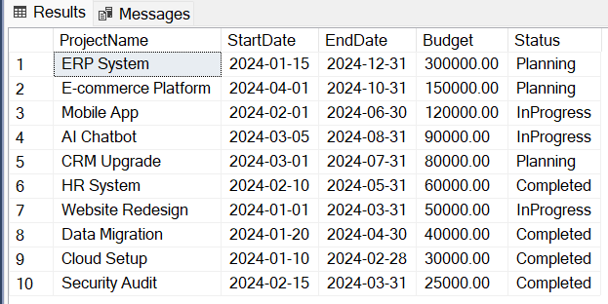
Câu lệnh này dùng ORDER BY để sắp xếp các dự án theo ngân sách giảm dần.
Báo cáo này giúp ban quản lý nhanh chóng xác định những dự án có chi phí lớn nhất.

2. Query using inner join
Code:
SELECT t.TaskID,
t.TaskName,
p.ProjectName,
ts.StatusName
FROM Tasks t
INNER JOIN Projects p
ON p.ProjectID = t.ProjectID
INNER JOIN TaskStatus ts
ON ts.StatusID = t.StatusID
WHERE ts.StatusName = N'InProgress';

Result:
This query uses INNER JOIN to retrieve tasks that are currently in progress.  It joins Tasks with Projects and TaskStatus to show the project name and task status. | 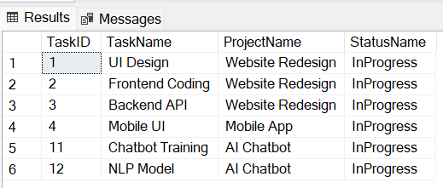

3. Query using aggregate function (COUNT)
Code:
SELECT COUNT(*) AS TotalCompletedTasks
FROM Tasks t
JOIN TaskStatus ts ON ts.StatusID = t.StatusID
WHERE ts.StatusName = N'Done';

Result:
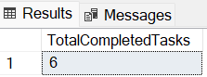
This query uses the COUNT(*) function to calculate the total number of completed tasks.
It is commonly used as a KPI for task completion tracking.

4. Query using aggregate functions with GROUP BY and ORDER BY
Code:
SELECT p.ProjectName,
SUM(pc.Amount) AS TotalCost
FROM ProjectCosts pc
JOIN Projects p ON p.ProjectID = pc.ProjectID
GROUP BY p.ProjectName
ORDER BY TotalCost DESC;

Result:
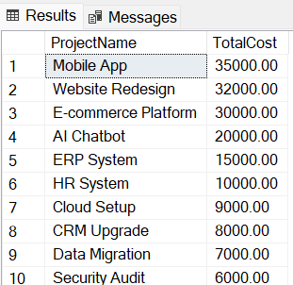
This query calculates the total cost for each project using SUM(Amount).
The result is sorted in descending order to highlight the most expensive projects.

5. Query using GROUP BY and HAVING
Code:
SELECT e.FullName,
COUNT(ta.TaskID) AS TotalTasks
FROM Employees e
JOIN TaskAssignments ta ON ta.EmployeeID = e.EmployeeID
GROUP BY e.FullName
HAVING COUNT(ta.TaskID) >= 2
ORDER BY TotalTasks DESC;

Result:
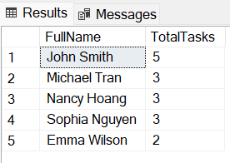
This query groups data by employee and counts the number of assigned tasks.
The HAVING clause filters employees who are assigned to two or more tasks, supporting workload analysis.

6. Query using a subquery
Code:
SELECT e.*
FROM Employees e
WHERE e.EmployeeID NOT IN (
SELECT DISTINCT ta.EmployeeID
FROM TaskAssignments ta
);

Result:
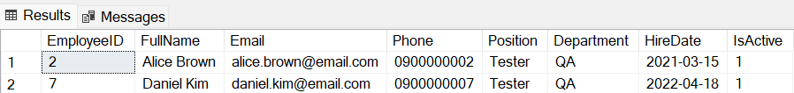
The subquery returns all employees who have task assignments.
The outer query retrieves employees who have not been assigned to any tasks, useful for resource planning.

7. Query using partial matching (LIKE)
Code:
SELECT *
FROM Projects
WHERE ProjectName LIKE N'%System%'
ORDER BY StartDate;

Result:
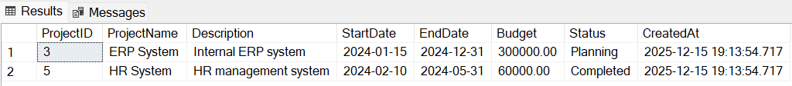
This query uses the LIKE operator for partial matching.
%System% matches any project name containing the word System, allowing quick filtering by keyword.

8. Query reporting total working hours per employee
Code:
SELECT e.FullName,
SUM(w.HoursWorked) AS TotalHours
FROM WorkLogs w
JOIN Employees e ON e.EmployeeID = w.EmployeeID
GROUP BY e.FullName
ORDER BY TotalHours DESC;

Result:
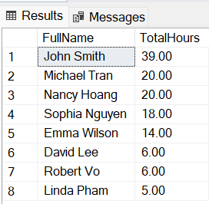
This query aggregates the total number of hours worked by each employee.
It is commonly used in productivity and utilization reports.

Views
- View – Project_Cost_Summary
Code:
CREATE OR ALTER VIEW dbo.Project_Cost_Summary
AS
SELECT p.ProjectID,
p.ProjectName,
p.Budget,
SUM(pc.Amount) AS TotalCost,
(p.Budget - SUM(pc.Amount)) AS RemainingBudget
FROM Projects p
LEFT JOIN ProjectCosts pc ON pc.ProjectID = p.ProjectID
GROUP BY p.ProjectID, p.ProjectName, p.Budget;
GO

-- Example call:
SELECT * FROM Project_Cost_Summary
Result:
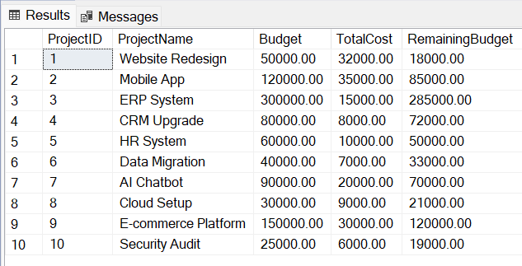
This view summarizes project financial information, including total cost and remaining budget.
It is commonly used for budget tracking and financial reporting.

- View – Employee_Workload
Code:
CREATE OR ALTER VIEW dbo.Employee_Workload
AS
SELECT e.EmployeeID,
e.FullName,
COUNT(DISTINCT ta.TaskID) AS TotalTasks,
SUM(w.HoursWorked) AS TotalHoursWorked
FROM Employees e
LEFT JOIN TaskAssignments ta ON ta.EmployeeID = e.EmployeeID
LEFT JOIN WorkLogs w ON w.EmployeeID = e.EmployeeID
GROUP BY e.EmployeeID, e.FullName;
GO

-- Example call:
SELECT * FROM Employee_Workload
Result:
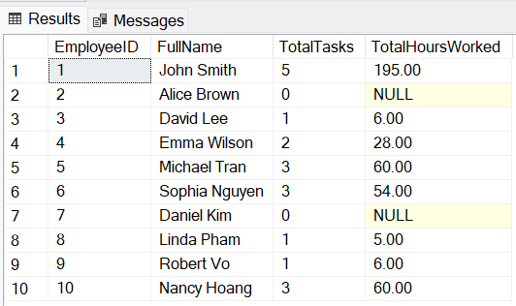
This view provides an overview of employee workload, including assigned tasks and total working hours.
It supports resource allocation and productivity analysis.

- View – Project_Task_Status
Code:
CREATE OR ALTER VIEW dbo.Project_Task_Status
AS
SELECT p.ProjectName,
ts.StatusName,
COUNT(t.TaskID) AS TotalTasks
FROM Projects p
JOIN Tasks t ON t.ProjectID = p.ProjectID
JOIN TaskStatus ts ON ts.StatusID = t.StatusID
GROUP BY p.ProjectName, ts.StatusName;
GO

-- Example call:
SELECT * FROM Project_Task_Status
Result:
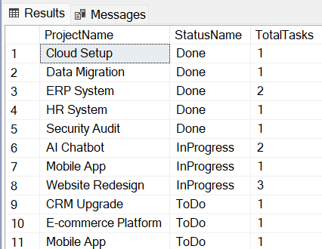
This view shows the distribution of task statuses per project.
It is useful for progress monitoring and status dashboards.

Stored Procedures
- Stored Procedure – Project_Information
Code:
CREATE OR ALTER PROC dbo.Project_Information
@ProjectID INT
AS
BEGIN
SET NOCOUNT ON;

SELECT p.ProjectID,
p.ProjectName,
p.StartDate,
p.EndDate,
p.Status,
COUNT(t.TaskID) AS TotalTasks,
AVG(pr.ProgressPercent) AS AverageProgress
FROM Projects p
LEFT JOIN Tasks t ON t.ProjectID = p.ProjectID
LEFT JOIN ProgressReports pr ON pr.TaskID = t.TaskID
WHERE p.ProjectID = @ProjectID
GROUP BY p.ProjectID, p.ProjectName, p.StartDate, p.EndDate, p.Status;
END
GO

-- Example call:
EXEC dbo.Project_Information @ProjectID = 1;
Result:
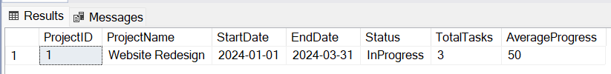
Given a ProjectID, this procedure returns project details, total tasks, and average progress percentage.
It provides a high-level project performance overview.

- Stored Procedure – Employee_Performance_Report
Code:
CREATE OR ALTER PROC dbo.Employee_Performance_Report
@EmployeeID INT
AS
BEGIN
SET NOCOUNT ON;

SELECT e.EmployeeID,
e.FullName,
COUNT(DISTINCT pr.ProjectID) AS TotalProjects,
AVG(pr.Score) AS AverageScore
FROM Employees e
LEFT JOIN PerformanceReviews pr ON pr.EmployeeID = e.EmployeeID
WHERE e.EmployeeID = @EmployeeID
GROUP BY e.EmployeeID, e.FullName;
END
GO

-- Example call:
EXEC dbo.Employee_Performance_Report @EmployeeID = 1;

Result:
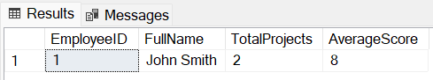
This stored procedure summarizes employee performance reviews, including total projects reviewed and average score.
It is typically used for HR evaluation and appraisal reporting.

- Stored Procedure – Task_Assignment_Details
Code:
CREATE OR ALTER PROC dbo.Task_Assignment_Details
@TaskID INT
AS
BEGIN
SET NOCOUNT ON;

SELECT t.TaskID,
t.TaskName,
p.ProjectName,
e.FullName,
ta.Role,
SUM(w.HoursWorked) AS TotalHoursWorked
FROM Tasks t
JOIN Projects p ON p.ProjectID = t.ProjectID
JOIN TaskAssignments ta ON ta.TaskID = t.TaskID
JOIN Employees e ON e.EmployeeID = ta.EmployeeID
LEFT JOIN WorkLogs w ON w.TaskID = t.TaskID
AND w.EmployeeID = e.EmployeeID
WHERE t.TaskID = @TaskID
GROUP BY t.TaskID, t.TaskName, p.ProjectName, e.FullName, ta.Role;
END
GO

-- Example call:
EXEC dbo.Task_Assignment_Details @TaskID = 1;
Result:
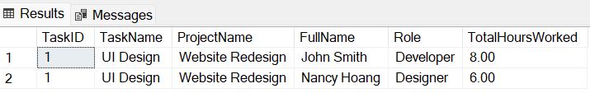
This procedure displays detailed assignment information for a specific task, including assigned employees, roles, and working hours.
It supports task tracking and effort analysis.

Triggers
- Trigger – Prevent Task End Date Before Start Date
Code:
CREATE OR ALTER TRIGGER dbo.TRG_Prevent_Invalid_Task_Dates
ON dbo.Tasks
INSTEAD OF INSERT, UPDATE
AS
BEGIN
SET NOCOUNT ON;

IF EXISTS (
SELECT 1
FROM inserted
WHERE EndDate IS NOT NULL
AND StartDate IS NOT NULL
AND EndDate < StartDate
)
BEGIN
PRINT N'EndDate cannot be earlier than StartDate.';
END
ELSE
BEGIN
INSERT INTO Tasks (ProjectID, TaskName, Description, StartDate, EndDate, Priority, StatusID)
SELECT ProjectID, TaskName, Description, StartDate, EndDate, Priority, StatusID
FROM inserted;
PRINT N'Task inserted/updated successfully.';
END
END
GO

-- Test query:
INSERT INTO Tasks (ProjectID, TaskName, StartDate, EndDate, Priority, StatusID)
VALUES (1, 'Invalid Date Task', '2024-03-10', '2024-03-01', 'High', 1);

Result:
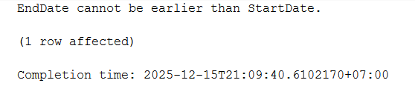
This trigger prevents tasks from being created or updated with an EndDate earlier than StartDate, ensuring data consistency for scheduling.

- Trigger – Prevent Duplicate Task Assignment to Same Employee
Code:
CREATE OR ALTER TRIGGER dbo.TRG_Prevent_Duplicate_Task_Assignment
ON dbo.TaskAssignments
INSTEAD OF INSERT
AS
BEGIN
SET NOCOUNT ON;

IF EXISTS (
SELECT 1
FROM inserted i
JOIN TaskAssignments ta
ON ta.TaskID = i.TaskID
AND ta.EmployeeID = i.EmployeeID
)
BEGIN
PRINT N'Employee is already assigned to this task.';
END
ELSE
BEGIN
INSERT INTO TaskAssignments (TaskID, EmployeeID, AssignedDate, Role)
SELECT TaskID, EmployeeID, AssignedDate, Role FROM inserted;
PRINT N'Task assignment added successfully.';
END
END
GO

-- Test query:
INSERT INTO TaskAssignments (TaskID, EmployeeID, Role)
VALUES (1, 1, 'Developer');

Result:
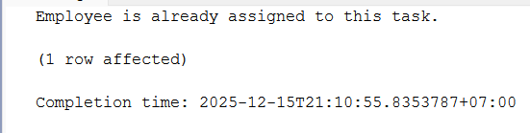
This trigger prevents assigning the same employee to the same task multiple times, avoiding duplicate workload records.

- Trigger – Automatically Mark Task as Done When Progress = 100%
Code:
CREATE OR ALTER TRIGGER dbo.TRG_Auto_Complete_Task
ON dbo.ProgressReports
AFTER INSERT, UPDATE
AS
BEGIN
SET NOCOUNT ON;

UPDATE t
SET StatusID = ts.StatusID
FROM Tasks t
JOIN inserted i ON i.TaskID = t.TaskID
JOIN TaskStatus ts ON ts.StatusName = N'Done'
WHERE i.ProgressPercent = 100;
END
GO
-- Test query:
INSERT INTO ProgressReports (TaskID, EmployeeID, ProgressPercent, Comment)
VALUES (2, 1, 100, 'Task completed');

Result:
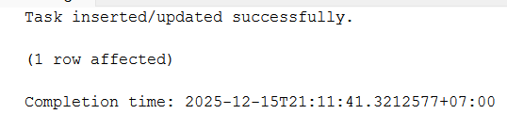
When a progress report reaches 100%, the trigger automatically updates the task status to Done, keeping task status synchronized with progress.

- Trigger – Prevent Negative or Excessive Work Hours
Code:
CREATE OR ALTER TRIGGER dbo.TRG_Validate_Work_Hours
ON dbo.WorkLogs
INSTEAD OF INSERT
AS
BEGIN
SET NOCOUNT ON;

IF EXISTS (
SELECT 1
FROM inserted
WHERE HoursWorked <= 0 OR HoursWorked > 24
)
BEGIN
PRINT N'Invalid working hours. Must be between 1 and 24.';
END
ELSE
BEGIN
INSERT INTO WorkLogs (TaskID, EmployeeID, WorkDate, HoursWorked, Note)
SELECT TaskID, EmployeeID, WorkDate, HoursWorked, Note
FROM inserted;
PRINT N'Work log added successfully.';
END
END
GO

-- Test query:
INSERT INTO WorkLogs (TaskID, EmployeeID, WorkDate, HoursWorked)
VALUES (1, 1, '2024-03-10', 30);

Result:
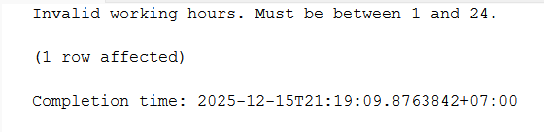
This trigger ensures realistic working hours, preventing incorrect time-tracking entries that could distort productivity reports.

PHẦN IX: KẾT QUẢ ĐẠT ĐƯỢC
- Xây dựng được CSDL hoàn chỉnh
- Thiết kế đúng chuẩn quan hệ
- Đáp ứng đầy đủ yêu cầu quản lý dự án
- Có thể mở rộng cho hệ thống thực tế

PHẦN X: KẾT LUẬN
Qua đề tài, nhóm rút ra:
- Ưu điểm: phân công rõ ràng, phối hợp hiệu quả
- Hạn chế: thời gian họp còn hạn chế, vẫn chưa hiểu rõ về nghiệp vụ
- Kinh nghiệm: hiểu rõ nghiệp vụ giúp thiết kế CSDL tốt hơn

